Lagan College

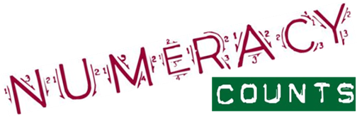
Summer Numeracy Puzzle Challenge

Name: ______________
Form class: _______

Dear Parent/Guardian and of course, students

At Lagan College we place the utmost importance on improving the numeracy skills of our students. We have a fortnightly puzzle that has either a numeracy or literacy theme to it. This booklet contains some numeracy puzzles, of varying difficultly, and a space to answer each of the puzzles.

The aim of the ‘Puzzle of the Fortnight’ is to enable students to increase their literacy and numeracy skills. It allows them to improve their numeracy skills and their confidence and competence to apply mathematical skills in routine and unfamiliar contexts.

Year 8 form classes will compete to see which class will get the most correct answers for the Puzzle of the Fortnight and merits are awarded to each pupil who correctly solves the puzzle each fortnight.

This booklet contains samples of the type of numeracy puzzle that are used or have previously been used. We expect each student to attempt the puzzles within this booklet and then hand the completed booklet to your new Maths teacher at the beginning of the school term.

Get your ‘thinking caps’ on – we hope you enjoy solving the puzzles.

Yours faithfully

Mrs L Grant
Head of Junior School

There is a new puzzle each fortnight
and you can enter by placing your
answers in the box in the Library

For each of the puzzles in this booklet there is a space to write your answer in.

Puzzle 1

How tall is a sapling that is 5m shorter than a fence that is 6 times higher than the sapling?

Answer: ____________________________

Puzzle 2

If you wrote down all the numbers from 1 to 100, how many times would you write down the number 3?

Answer: ____________________________

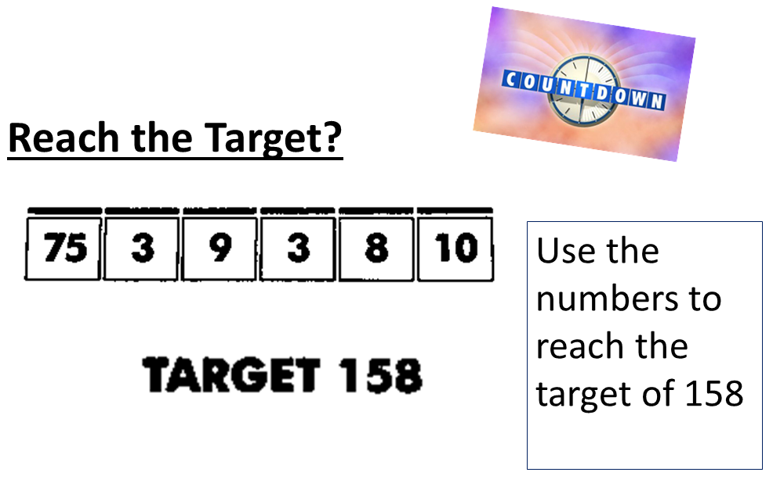
Puzzle 3

Show your working out

Puzzle 4 – Calendar Confusion
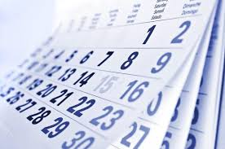
Three days ago, yesterday was the day before Sunday. What day will it be tomorrow?

Answer: _______________________________

Puzzle 5 – Balloon Bursting

If a number in one of the balloons is included in the answers to the three problems below then that balloon will fly away.

Answer: _____________________

Puzzle 6 - Calculator Words

Did you know that you can read words on your calculator? You can if you turn it upside down!

Find a calculator. Got it? Good.

Now type in 0.7734 Turn the display upside down. Hello!

Try these sums on your calculator. Turn the answer upside down and you should get a word.

We have given you some clues so you may be able to guess the word before you start.

1. 39459 ÷ 7 = _________________________________
(Spiders have 8 but millipedes do not have millions)

2. 15469 x 5 = __________________________________
(Put it to your ear and you may hear the sea.)

3. The square root of 59876644 = ________________________
(It sounds like he invented the telephone.)

4. 10000 – 9393 = __________________________________
(It's easy to fall off this )

5. 1792202 x 3 = __________________________________
(Put these on to see underwater)

There are loads more words you can make up. Try them for yourself. Can you make a five letter word?

My five letter word is ___________________________

Puzzle 7 – About Time!
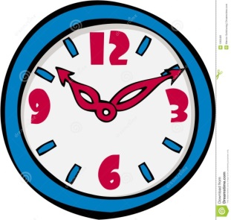
How much time is there between 22.06 today and 11.43 tomorrow?

Answer: __________________________

Puzzle 8 – Summing Up

How can I get the answer 13 by only using the numbers
7,8,4,3
You can add, subtract, multiply and divide

Show your working out

Puzzle 9 – How many?

How many triangles can you see?

Answer: __________________

Puzzle 10 – Join the dots.

Connect these nine dots by drawing four straight lines through these nine dots without lifting the pen or pencil from the paper.

