

**QUIZ BOOK**

**for new Year 8 students**

**NAME:**

**_______________________________________**



**Welcome to the Passport to Lagan Quiz Book!**

We hope that as you work through this book you will learn more about Lagan College and the school community which you will become a part of in September ☺

To find the answers to the different activities in this book, you will have to visit the Passport to Lagan website at:

[**www.passporttolagan.weebly.com**](http://www.passporttolagan.weebly.com)

The password to get into the site is p7tolagan

We hope you enjoy working your way through this quiz book! If you have any questions you would like us to answer, there is a link on the website to send these to us!

Make sure you bring this book with you on the first day of school, as you will be going through it in your form class!

**Lagan’s BIG MESSAGES**

At Lagan College, we have four big messages that we follow – you can find these on the website in the “About the school” section.

In the table below, write the name of each of our “Big Message” values and explain it in your own words:

|  |  |
| --- | --- |
|  |  |
|  |  |
|  |  |
|  |  |

Draw a picture below showing how you might show one of these values in the way you act towards others:

[](http://www.google.co.uk/url?sa=i&rct=j&q=&esrc=s&source=images&cd=&cad=rja&uact=8&ved=0ahUKEwiLr5urz4vNAhXmD8AKHdSWDQwQjRwIBw&url=http%3A%2F%2Fwww.wholemusicllc.com%2Fwm-blog%2F2014%2F12%2F13%2Fmusic-and-school-music-supports-all-school-subjects&psig=AFQjCNEtVl7sxGphdsK4NJyOPhaDoOblUw&ust=1465035121087125)**SCHOOL SUBJECTS**

On the website, if you go to the “Life in Year 8” link at the top of the page, then “New subjects”, you’ll find a file called “Curriculum Overview”. Open it up and read it.

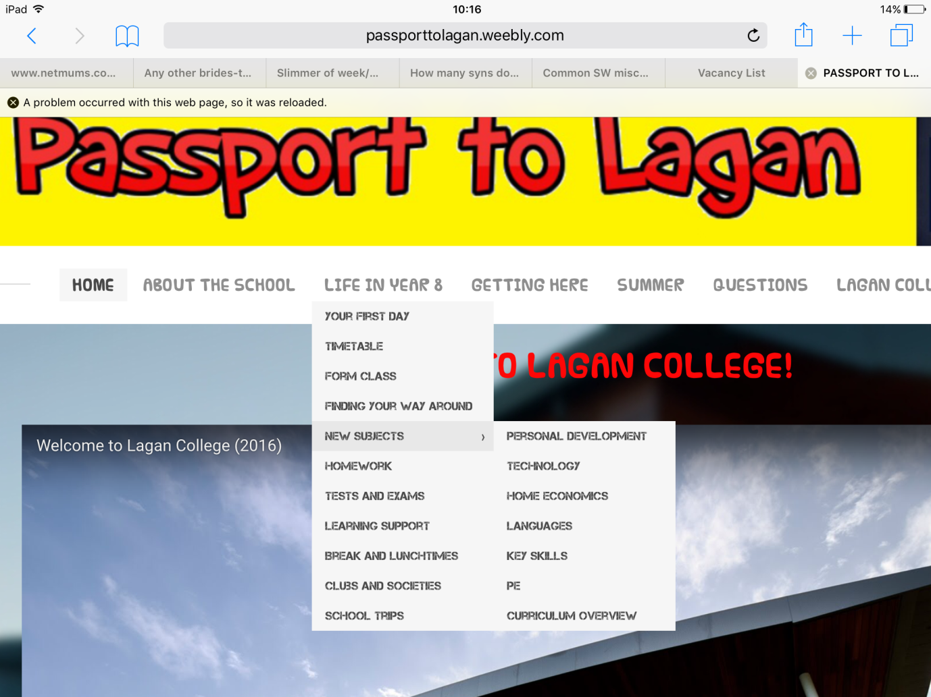

From what you have read, answer these questions:

What do you think will be the most fun subject to study in Year 8? Why?

_________________________________________________________________________________________________________________________________________________________________________________

What subject do you think you will find the most difficult? Why?

_________________________________________________________________________________________________________________________________________________________________________________

It says that in English you will present a ‘Me Box’ – this is a box where you put items that tell people something about you / your family / your hobbies. Can you think of one object you would include and explain why you would include it?

_________________________________________________________________________________________________________________________________________________________________________________

[](http://www.google.co.uk/url?sa=i&rct=j&q=&esrc=s&source=images&cd=&cad=rja&uact=8&ved=0ahUKEwiQzdDCz4vNAhWkBsAKHWe8BmQQjRwIBw&url=http://freecoloringpages.co.uk/?q=to+make+clock&bvm=bv.123664746,d.ZGg&psig=AFQjCNGjGMchltVqIEdTV1Im0ntUVnWUJQ&ust=1465035176591831)

**SCHOOL TIMETABLE**

Following a timetable where you have to move between classes and rooms probably seems quite confusing, but you’ll soon get used to it!

Each box on the timetable shows what class you have at each time, what room you are in and who your teacher is.

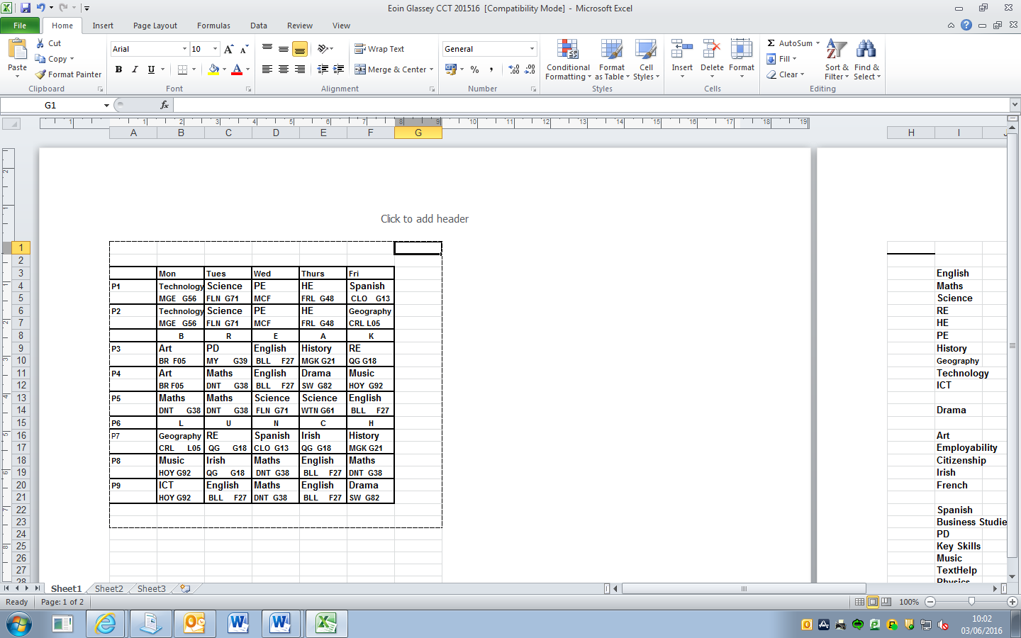For example, this box shows us that this student has RE Period 3 on a Friday in Room G18. If we look at the code underneath, we can see that their teacher is Mrs Quigg.

**TEACHER CODES**

BLL Miss Bell HOY Miss Hoy

BR Mr Burch MCF Mr McFadden

CLO Mrs Castillo MGK Mr McGuckin

CRL Mrs Carlisle MY Mr Mooney

DNT Mrs Danter QG Mrs Quigg

FLN Mrs Fullerton SW Mrs Seawright

FRL Miss Fairley WTN Miss Wightman

Use the timetable above to answer these questions:

1. What subject does this student have straight after break on a Monday?
2. Who is their Geography teacher?
3. On what day does this student have to remember their PE kit?
4. How many periods of English does this student have in a whole week?
5. What room are they in for Music?
6. What other subject do they have in the same room?
7. Who is their teacher for Spanish?
8. What would be your favourite day if this was your timetable?

**SCHOOL BADGE**

On the website, go to the “About the school” link in the top menu and go to the page called ”School Badge”. Here you can read about our school badge and what each of the parts of it mean.

In the box below, design your own school badge for Lagan College. Use plenty of colour and be creative!

In the space below your drawing, explain what two different parts of your badge show, and what the meaning is behind them. You can use the meanings behind parts of our school badge to help you come up with ideas!

1.________________________________________________________________________________________________________________________________________________________________________________

2.________________________________________________________________________________________________________________________________________________________________________________

**CROSSWORD – See how many of the answers**

**you can find on the website!**

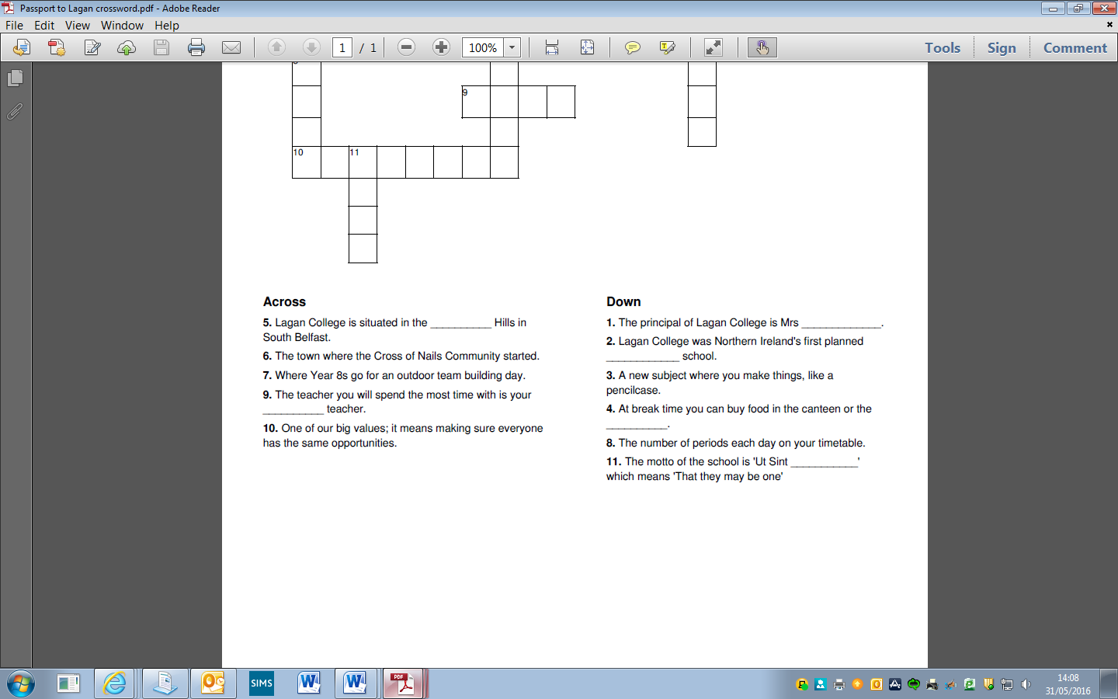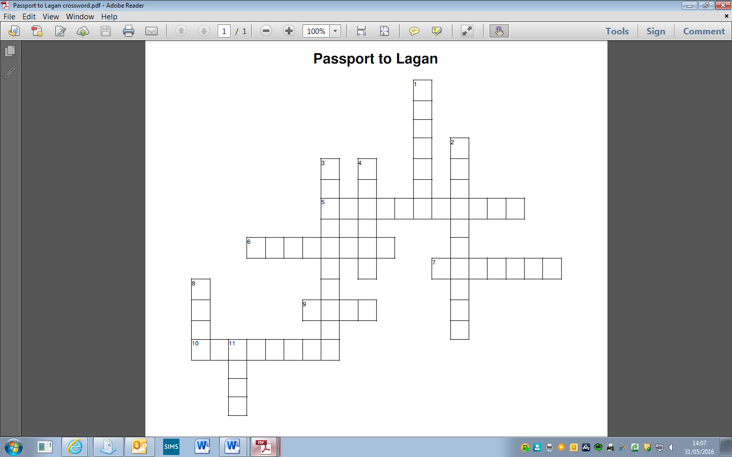

**YOU HAVE COMPLETED THIS WORKBOOK!**

**WELL DONE!**



Remember to make sure you complete your Reading and Maths challenges as well, and bring them all with you on the first day of school! You will be going over them in your Form Class.

If you have any more questions or worries in the meantime, send them to us using the “Questions” link on the website.

See you after the Summer!